Laboratory Assignment 1
Introduction
One of the most important aspects that determine the productivity of employees is the type of workplace they work in. A workplace plays a critical role in career development, allows individuals to pursue their career objectives, and provides a space for excellence and alignment with a person's values and personality. Having a conducive work environment is necessary because it affects the social, wellbeing, efficiency, workplace collaboration, and the health of employees. According to Stone, Hughes, and Dailey (2008), designing an effective office based work environment is essential because it improves productivity, work quality, efficiency, and overall performance. Because of my personality and values as well as the upcoming course activity (determining the effects of the Covid-19 on oil prices), the most effective office-based environment is an investigative environment. Selecting this office-based environment will ensure that I can experiment, think critically, and develop solutions to existing challenges.
Investigative office-based environment
An investigative work environment can be defined as a workplace that allows a person to gather information, use critical thinking skills, make connections and interpretations of data before making conclusions. It is an excellent environment for thinkers, particularly in engineering, health, and technology sectors where innovation and creative solutions are key to success. Developing this environment will be important for the upcoming class activity where learners will be required to investigate on the effects of the Covid-19 on oil plummeting oil prices. Also, the activity will allows learners to develop effective success strategies that can be used to address future uncertainties in the sector.
An investigative work environment will be vital for this course activity because learners will need to critically think on the most viable solutions to stabilize oil prices as the world continues to battle with the Covid-19 pandemic. Designing such an environment will guarantee that I can achieve the objectives of the class activity and complete it successfully.
Software installation steps
The success of the activity in the office-based environment will be dependent on the type of software that will be installed. Today, there are numerous software that can be used to enhance work outcomes. For this office, the type of software that would improve my outcomes is Microsoft Office 365. This software is designed to help track and manage investigations. Office 365 allows an individual to subscribe to different services, which can allow users to use Ms word, Excell, PowerPoint, Outlook, and OneNote (Microsoft, 2021). Having access to these services over the internet will be important during the investigation because the available tools can be used to improve analysis of data, identification of trends, and development of conclusions.
Step 1
Open the browser and go to office.com
Step 2
Sign in to Microsoft account

Step 3
Select install office
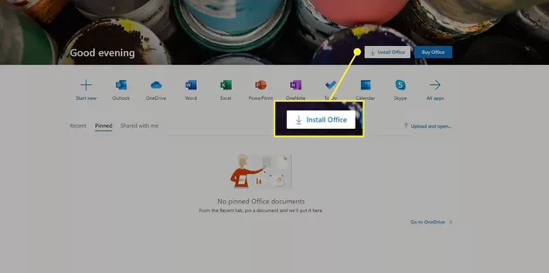
Step 4
Select install office on the Microsoft 365 home web
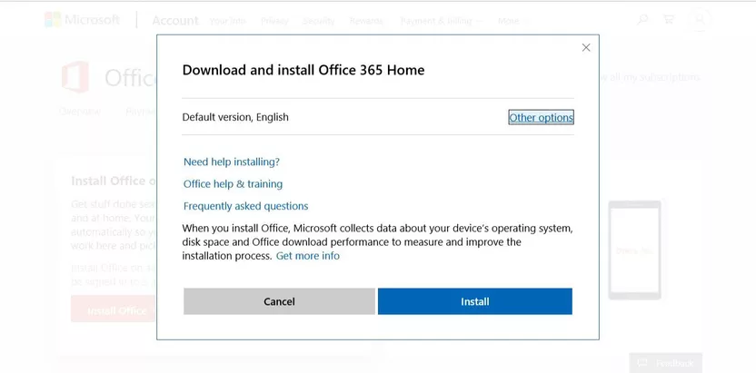
Step 5
On the download and install Microsoft 365 Home screen select install
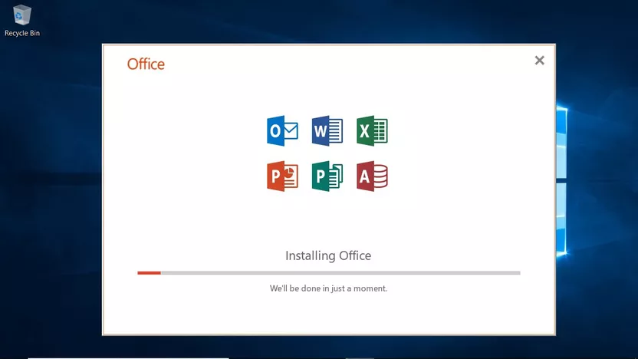
Step 6
Select the run prompt
Step 7
Activate the subscription after office has been installed.
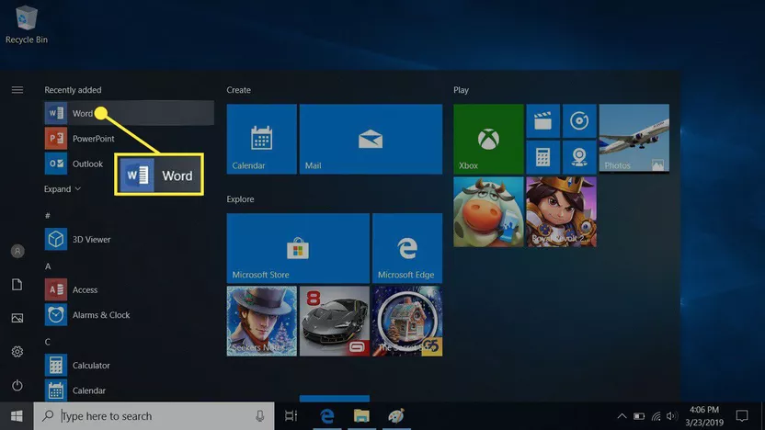

References
Microsoft. (2021). Microsoft 365 and Office 365 platform service description. https://docs.microsoft.com/en-us/office365/servicedescriptions/office-365-platform-service-description/office-365-platform-service-description
Stone PW, Hughes R, Dailey M. (2008). Creating a Safe and High-Quality Health Care Environment. In: Hughes RG, editor. Patient Safety and Quality: An Evidence-Based Handbook for Nurses. Rockville (MD): Agency for Healthcare Research and Quality (US); Chapter 21.
Laboratory Assignment 2
Hardware and Storage Consideration
Before setting up hardware and storage considerations, it is necessary to have an understanding of the regular and critical activities that the office will focus on most of the time. Based on the fact that this is an investigative office, it will be necessary to have effective hardware and storage facilities to ensure that all information is stored safely and can be readily accessed. In a 2019 report by Campbell, published the U.S. Small Business Administration, it was identified that it is necessary to address factors like storage capacity, speed and performance, the range of features that will be needed, mobility, and budget.
Hardware that will be used include desktop computers, external hard drives, servers, printer, telephones, thumb drives, scanners, projector, power supply, and heat sink. These hardware will play a critical role during the investigation, helping in documentation, storage, and processing of information to gather trends and make informed conclusions. Peripheral devices that will be required include mouse, keyboards, web cams, graphic cards, and microphones. The office will need connectivity devices that will enable internet access. These will include wireless access points, Trans receivers, switch, network interface card, network server solutions, wireless router, thr bridge and the hub. Also, it will be necessary to have different software that will improve on the outcomes of the activity. The software that will be used will include I-Sight case management software, predictive analytics, structured query language (SQL), python statistical programming, and data visualization.SQL is a standard database language that is used in almost all organizations to manage and store data, make comparisons between different databases, and build database structures. Data visualization is data analytics tool that uses charts, tables, graphs, and other visuals to present data. It is an important skill because it allows users to present data and understand it easily. Using these software technologies will be important during the class activity because of the large volumes of data that will be analyzed. Selection of these software was made on the basis of capacity to analyse vast volumes of data and ability to provide trends and make connections.
The estimated costs for the installation of hardware will be $475.2 and for the software is up to $3500. The costs of software will be determined by maintenance, redesign, training, upgrades, implementation, and support. All these activities will lead to the accumulation of extra costs.
Selected Technologies

I-Sight Case Management Software
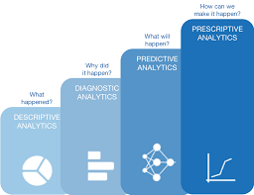
Predictive analytics

Structured query language (SQL)

Python statistical programming

Data visualization
Having excellent hardware and software will ensure that there is optimal performance, which will enable me to achieve the objectives of the assigned class activity.
References
Campbell, A. (2019). 5 Considerations When Choosing Hardware for your Business. https://www.sba.gov/blog/5-considerations-when-choosing-hardware-your-business

